DESIGN AND IMPLEMENTATION USING ENCRYPTION AND DECRPTION SYSTEM USING A NIHILIST TRANSPOSITION CIPHER

BY
S/N | NAMES | REGISTRATION NUMBER
 | MUHAMMED MUHAMMED WAKILI | ND/CS/23/015
 | MOHAMMED MOHAMMED SHEHU | ND/CS/23/046
 | ABDULAZEEZ MOHAMMED | ND/CS/23/011

A PROJECT SUBMITTED TO THE DEPARTMENT OF COMPUTER SCIENCE, SCHOOL OF SCIENCE AND TECHNOLOGY, GOMBE STATE POLYTECHNIC BAJOGA IN PARTIAL FULFILLMENT OF THE REQUIREMENT FOR THE AWARD OF NATIONAL DIPLOMA (ND) IN COMPUTER SCIENCE

APRIL, 2025

DECLARATION
We hereby declare that this work is the product of our research effort, under taken under the supervision of “Malam Sulaiman Kallamu” and has not been presented and will not be presented elsewhere for the award of ND certificate. All source have been duly acknowledged.
S/N | NAMES | SIGNATURE
 | MUHAMMED MUHAMMED WAKILI
 | MOHAMMED MOHAMMED SHEHU
 | ABDULAZEEZ MOHAMMED

CERTIFICATION
This is to certify that the project titled “Design And Implementation Using Encryption And Description System Using A Nihilist Transposition Cipher
” was carried out under the supervision of:

………………………………… ………………………….………
MALAM SULAIMAN KALLAMU DATE
PROJECT SUPERVISOR

………………………………… ………………………….………
MR. ISMAIL ABDULKARIM ADAMU DATE
HEAD OF DEPARTMENT

ACKNOWLEDGMENT
Our deep gratitude goes to Almighty Allah the creator of the creation. This work is a synergistic product of many minds and we feel a deep sense of gratitude to our parents, brothers and sisters our friends for their encouragement and for being ever supportive. Our sincere thanks goes to our supervisor Malam Sulaiman Kallamu for his thorough assistance with this work.
We appreciate the effort and care of the Head of Computer Science Department Mr. Ismail Abdulkarim Adamu. We also acknowledge the Computer Science Students (set 2025) for their active verbal participation and suggestions towards the evolvement of this project work.

DEDICATION
To our parents, our beloved once, the department of computer science and the computer scientist in general.

ABSTRACT
This paper presents the design and implementation of a secure encryption and decryption system employing the Nihilist Transposition cipher. Classical transposition ciphers rearrange the order of characters, while the Nihilist Transposition combines this with a keyword-based columnar transposition, offering enhanced security compared to simple transposition techniques. This project details the development of a software application, built with [mention technologies used, e.g., Python, Java], capable of encrypting plaintext messages using a user-defined keyword and decrypting ciphertext back to its original form. The system implements the specific steps of the Nihilist Transposition, including keyword processing, matrix construction for transposition, and the application of the columnar transposition algorithm. The paper discusses the design choices made during development, the implementation details of the encryption and decryption functions, and the user interface considerations. Furthermore, the system's functionality is evaluated through testing with various plaintext inputs and keywords to demonstrate its ability to correctly encrypt and decrypt messages. This implementation provides a practical understanding of the Nihilist Transposition cipher and its application in secure communication.

Table of Contents
DECLARATION ii
CERTIFICATION iii
ACKNOWLEDGMENT iv
DEDICATION v
ABSTRACT vi
LIST OF FIGURES x
CHAPTER ONE 1
INTRODUCTION 1
1.1 Background of the Study 1
1.2 Statement of the Problem 2
1.3 Justification of the Study 2
1.4 Aim and Objectives 3
1.5 Scope of the Study 3
1.6 Limitations of the Study 3
1.7 Resources and Technologies Used 4
1.8 Definition of Key Terms 4
1.9 Chapterization Overview 4
CHAPTER TWO 6
LITERATURE REVIEW 6
2.1 Introduction 6
2.2 Overview of Classical Cryptography 7
2.3 The Nihilist Cipher 8
2.3.1 Encryption Process 8
2.3.2 Decryption Process 9
2.4 Modern Cryptographic Techniques and Their Evolution 10
2.4.1 Comparison of Classical and Modern Cryptography 11
2.5 Gaps in Existing Literature 13
2.6 Contribution of This Research 13
CHAPTER THREE 15
METHODOLOGY 15
3.1 Introduction 15
3.2 Preliminary Investigation 15
3.2.1 Fact-Finding Techniques 16
3.3 Feasibility Study 16
3.3.1 Technical Feasibility 17
3.3.2 Economic Feasibility 17
3.3.3 Operational Feasibility 17
3.4 Overview of the Existing System 17
3.5 Analysis of the Existing System 19
3.6 Overview of the Proposed System 19
Proposed System Diagram 20
Use Case Diagram 20
3.7 Analysis of the Proposed System 20
3.8 System Design 20
3.8.1 Logical Design 20
3.8.2 Physical Design 21
Physical Design Diagram 21
Entity Relation Diagram 22
CHAPTER FOUR 23
SYSTEM IMPLEMENTATION AND TESTING 23
4.1 Introduction 23
4.2 System Implementation 23
4.2.1 Development Tools and Technologies 23
4.2.2 System Architecture 24
4.3 System Testing 24
4.3.1 Testing Methodologies 24
4.3.2 Test Cases and Expected Results 25
4.4 Evaluation of Results 25
4.5 Challenges and Limitations 25
CHAPTER FIVE 26
SUMMARY, CONCLUSION, AND RECOMMENDATIONS 26
5.1 Introduction 26
5.2 Summary of Findings 26
5.3 Achievements of the Study 26
5.4 Challenges Encountered 27
5.5 Recommendations 27
REFERENCES 28
APPENDIX 30
Appendix A: System Screenshots 30
Appendix B: Database Schema 32
Appendix C: Source Code Snippets 32
Encryption Function (PHP Implementation) 32
Decryption Function (PHP Implementation) 33

LIST OF FIGURES
Existing System Diagram 18
Use Case Diagram 20
Entity-Relationship Diagram (ERD) 22

CHAPTER ONE

INTRODUCTION

1.1 Background of the Study
Cryptography plays a crucial role in securing digital communication, ensuring that sensitive information remains confidential and protected from unauthorized access. Over the years, cryptographic methods have evolved from simple pen-and-paper ciphers to complex algorithmic encryption techniques that secure modern digital transactions, government communications, and military operations. The need for secure communication has become even more critical in today's digital age, where cyber threats such as hacking, data breaches, and identity theft are prevalent.
Among classical encryption techniques, the Nihilist Cipher stands out as a hybrid transposition-substitution cipher that evolved from the Polybius square. This cipher was historically used for military-grade encryption, making it a preferred choice for secure message transmission in the 19th and early 20th centuries. Unlike simpler ciphers such as the Caesar Cipher or the Atbash Cipher, the Nihilist Cipher introduced additional layers of security through the use of a numerical key and a grid-based encoding system. These features made it less susceptible to direct frequency analysis attacks, a major vulnerability in early encryption methods.
With the rise of cyber threats in the digital era, modern encryption techniques such as AES (Advanced Encryption Standard), RSA (Rivest-Shamir-Adleman), and ECC (Elliptic Curve Cryptography) have become the standard for digital security. These encryption schemes leverage mathematical complexity and computational power to provide robust security solutions for applications such as online banking, cloud storage, and secure messaging. However, classical encryption methods like the Nihilist Cipher remain relevant for foundational cryptographic research, especially in the study of lightweight encryption mechanisms that require minimal computational resources.
Despite its historical significance, the Nihilist Cipher has not been widely implemented in modern encryption software, mainly due to its perceived limitations in security and key management. However, its unique structure and mathematical principles provide valuable insights into the evolution of cryptographic techniques. Classical encryption methods like the Nihilist Cipher can still serve specialized purposes, such as:
- Lightweight encryption for embedded systems (IoT devices with low computational power).
- Educational tools for teaching cryptographic principles in academic settings.
- Offline encryption systems where computational resources are limited.
This study explores the design and implementation of an encryption and decryption system using the Nihilist Cipher, emphasizing its effectiveness in securing textual communication. The project will demonstrate how classical encryption techniques can still be applied in modern digital security frameworks, offering insights into their strengths, weaknesses, and potential enhancements.

1.2 Statement of the Problem
Despite advancements in cryptography, many encryption methods face challenges related to efficiency, complexity, and computational cost. The Nihilist Cipher, while effective against simple frequency analysis, remains underutilized due to limited research on its practical implementation in modern security frameworks.
Key issues include:
- Lack of modern implementations: Most research focuses on theoretical analysis rather than software development.
- Security limitations: The vulnerability of the Nihilist Cipher to brute-force attacks needs further evaluation.
- Limited usability: No widely available applications integrate this cipher for modern encryption needs.
This study aims to bridge these gaps by developing a functional encryption-decryption system using the Nihilist Cipher, evaluating its performance, security, and usability.

1.3 Justification of the Study
The study is significant in both academic and practical cryptographic research because:
- It provides a modern software implementation of the Nihilist Cipher.
- It evaluates the cipher's effectiveness in secure communication.
- It contributes to the understanding of classical encryption techniques and their potential adaptations in modern security applications.
- It serves as an educational resource for cryptography students and researchers.

1.4 Aim and Objectives
Aim
To design and implement an encryption and decryption system using the Nihilist Cipher for secure communication.
Objectives
- To develop a functional software system that implements the Nihilist Cipher for encryption and decryption.
- To evaluate the security effectiveness of the cipher against modern cryptanalysis techniques.
- To analyze its performance in terms of encryption speed and resource utilization.
- To provide a user-friendly web-based interface for secure message encryption and retrieval.
- To explore the applicability of the Nihilist Cipher in lightweight encryption scenarios.

1.5 Scope of the Study
This study focuses on:
- Implementing the Nihilist Cipher algorithm using PHP and MySQL.
- Encrypting and decrypting text-based messages with a user-defined numeric key.
- Storing encrypted messages securely in a database for future reference.
- Evaluating the system’s performance, security, and usability.
The study does not cover advanced cryptographic attacks or hybrid encryption methods combining multiple ciphers.

1.6 Limitations of the Study
- The system relies on manual key input, making it susceptible to user errors.
- The Nihilist Cipher is vulnerable to brute-force attacks if the key is too short.
- The study focuses on text-based encryption only, excluding images, files, and multimedia encryption.
- The system is designed for educational and research purposes, not for enterprise-level security.

1.7 Resources and Technologies Used
The system is developed using the following technologies:
Resource | Purpose
PHP & MySQL | Backend development & database management
HTML, CSS, Bootstrap | Frontend user interface
XAMPP | Local server for testing
JavaScript | Client-side enhancements

1.8 Definition of Key Terms
- Cryptography: The practice of securing communication through encryption techniques.
- Nihilist Cipher: A classical encryption method combining substitution and transposition.
- Encryption: The process of converting plaintext into unreadable ciphertext.
- Decryption: The process of reversing encryption to retrieve the original plaintext.
- Key: A numeric value used in the encryption and decryption process.
- Ciphertext: The encrypted form of a message.

1.9 Chapterization Overview
- Chapter One introduces the research, outlines the problem statement, objectives, scope, and significance.
- Chapter Two reviews existing literature on cryptographic techniques and the Nihilist Cipher.
- Chapter Three details the methodology, including system design, development, and testing.
- Chapter Four presents implementation results and performance evaluation.
- Chapter Five summarizes findings, provides conclusions, and suggests recommendations.

CHAPTER TWO

LITERATURE REVIEW

2.1 Introduction
A literature review provides a comprehensive analysis of existing research, theories, and methodologies related to the subject under study. It serves as a foundation for understanding previous studies, identifying gaps in knowledge, and establishing the relevance of the current research. In cryptography, the study of encryption techniques has been an area of extensive research, particularly in the evolution of classical and modern cryptographic methods. The ability to securely store, transmit, and retrieve sensitive information is fundamental in today's interconnected world, where cyber threats continue to pose risks to individuals, organizations, and governments.
This chapter explores the existing body of knowledge on cryptographic techniques, particularly focusing on the Nihilist Cipher, a classical encryption method that combines substitution and transposition principles. The Nihilist Cipher, which evolved from the Polybius square, played a significant role in historical military communications and continues to be studied for its mathematical structure and encryption principles. While modern cryptography has largely shifted towards algorithmic-based security solutions such as AES, RSA, and ECC, classical cryptographic techniques provide valuable insights into the fundamental principles of secure communication and their potential adaptations in contemporary security frameworks.
This chapter also examines the evolution of cryptography, from its early use in ancient civilizations to its application in modern digital security. The strengths and limitations of classical encryption methods are critically analyzed, with particular emphasis on their resilience to cryptanalysis techniques, efficiency in resource-constrained environments, and feasibility for lightweight encryption applications. The transition to modern cryptographic practices is discussed, highlighting how computational advancements have enabled stronger encryption algorithms and addressing the security weaknesses inherent in classical ciphers.
Additionally, this review highlights existing research gaps in the study and implementation of the Nihilist Cipher, particularly in the context of modern security applications. While much of the existing literature focuses on historical analysis and theoretical discussions, fewer studies have explored practical implementations, security evaluations, and real-world applications of the Nihilist Cipher in contemporary settings. This study aims to bridge these gaps by developing a functional encryption-decryption system based on the Nihilist Cipher and evaluating its performance, security, and usability compared to modern cryptographic techniques.
Furthermore, the chapter explores the role of classical encryption in contemporary security applications, particularly in offline encryption systems, educational tools for cryptographic studies, and low-resource computing environments. It examines how classical encryption techniques, despite their age, can still offer practical benefits in scenarios where modern encryption algorithms are too computationally intensive or unavailable due to infrastructure limitations. By analyzing prior research, this study provides a theoretical and empirical foundation for understanding the applicability and limitations of the Nihilist Cipher and its potential adaptation in modern computing environments.

2.2 Overview of Classical Cryptography
Cryptography has evolved from simple substitution and transposition ciphers to complex cryptographic algorithms used in modern security systems. Classical encryption methods, such as the Caesar cipher, Vigenère cipher, and Nihilist cipher, laid the foundation for contemporary encryption techniques (Singh, 2019). These ciphers rely on simple mathematical transformations and key-based encryption, making them an essential study area for understanding modern cryptographic systems.
Classical ciphers can be categorized into two main types:
- Substitution Ciphers: These involve replacing characters in the plaintext with other characters or symbols. Examples include the Caesar cipher, Atbash cipher, and Polybius square.
- Transposition Ciphers: These involve rearranging the characters in the plaintext according to a predetermined pattern. Examples include the Rail Fence cipher and Columnar Transposition cipher.
The Nihilist cipher is a hybrid method that incorporates both substitution and transposition principles, making it more resistant to direct frequency analysis attacks. Understanding classical cryptography is crucial for analyzing the weaknesses that led to the development of stronger modern encryption techniques.

2.3 The Nihilist Cipher
The Nihilist Cipher is an advanced polyalphabetic substitution cipher that extends the Polybius square. It was historically used for secure military communication, particularly in the 19th century, due to its ability to obscure plaintext messages and make them difficult to decipher without the correct key (Kahn, 2018). Unlike simpler encryption techniques such as the Caesar Cipher, which merely shifts letters by a fixed number, or the Vigenère Cipher, which uses repeated key sequences, the Nihilist Cipher combines numerical substitution and transposition techniques, making it considerably more complex and secure.
One of the key advantages of the Nihilist Cipher over other classical ciphers is its dual-layer encryption process, where both numeric encoding and modular arithmetic are applied to obscure the plaintext. This approach significantly reduces the effectiveness of frequency analysis attacks, which are commonly used to break traditional monoalphabetic ciphers. Additionally, the Nihilist Cipher introduces variable-length encryption keys, further increasing its resistance to decryption attempts.
Despite its historical significance, the Nihilist Cipher remains an area of interest in cryptographic research due to its unique structure and mathematical principles. While modern encryption algorithms such as AES (Advanced Encryption Standard) and RSA (Rivest-Shamir-Adleman) have largely replaced classical ciphers, the Nihilist Cipher is still studied in cryptographic theory for its educational value, historical importance, and potential application in lightweight encryption scenarios.

2.3.1 Encryption Process
The Nihilist Cipher encrypts plaintext by first converting letters into numerical equivalents based on a predefined Polybius square. A numerical key is then applied to further obscure the message using modular arithmetic, creating an encryption system that is significantly more complex than simple substitution ciphers. This dual-layer encryption method enhances security and makes the cipher resistant to frequency analysis attacks (Schneier, 2020).
The encryption process follows these key steps:
- Constructing a Polybius square with a chosen keyword to define the numeric grid. The keyword helps introduce an additional layer of randomness, making the cipher more secure.
- Converting plaintext into numerical coordinates based on the Polybius square. Each letter is assigned a unique numerical value according to its position in the grid.
- Adding the numerical key values to the plaintext coordinates using modular arithmetic. This step ensures that even identical plaintext letters result in different ciphertext outputs, significantly strengthening the encryption.
- Formatting the encrypted message for transmission, typically by grouping digits into structured blocks to prevent easy decryption attempts.
This encryption process enhances security but also introduces complexity in manual decryption, as each step must be carefully reversed to retrieve the original message.

2.3.2 Decryption Process
Decryption involves reversing the encryption process by subtracting the numerical key from the ciphertext values and mapping them back to their corresponding letters in the Polybius square. This ensures that the original plaintext message is reconstructed accurately, provided that the correct key is used.
Despite its enhanced security compared to other classical ciphers, the Nihilist Cipher is still vulnerable to modern cryptanalysis techniques if:
- The key length is too short, making brute-force attacks more effective.
- The same key is reused across multiple messages, allowing attackers to analyze patterns and deduce the encryption method.
Challenges Associated with Decryption
While the Nihilist Cipher provides a higher level of security than simpler classical ciphers, it also presents several challenges in decryption, including:
- Key Management Issues: If the key is lost, misinterpreted, or incorrectly applied, decryption becomes impossible, leaving the message permanently unreadable.
- Padding Considerations: Messages often require padding to maintain structure, especially when the plaintext length does not align perfectly with the key length. This can lead to ambiguity in decryption, particularly if padding characters are not properly removed.
- Computational Complexity: Unlike modern symmetric encryption algorithms, which can efficiently encrypt and decrypt messages using high-speed computations, manual decryption of the Nihilist Cipher is slow and error-prone, making it impractical for large-scale applications.
Despite these challenges, the Nihilist Cipher remains a crucial subject of study in cryptographic history and is still used for educational, experimental, and lightweight encryption applications.

2.4 Modern Cryptographic Techniques and Their Evolution
With the advent of computers, encryption techniques have evolved significantly, shifting from manual pen-and-paper encryption methods to complex algorithmic-based encryption techniques designed to secure digital communication, financial transactions, cloud computing, and national security systems. The increasing prevalence of cyber threats, such as data breaches, identity theft, and cyber warfare, has driven the development of stronger cryptographic standards to ensure confidentiality, integrity, and authenticity in modern digital systems.
Modern cryptographic techniques are classified into two main categories:
- Symmetric Encryption: The same secret key is used for both encryption and decryption. Examples include AES (Advanced Encryption Standard) and DES (Data Encryption Standard).
- Asymmetric Encryption: Different keys are used for encryption and decryption—one public and one private. Examples include RSA (Rivest-Shamir-Adleman), ECC (Elliptic Curve Cryptography), and Diffie-Hellman key exchange.
These modern encryption techniques leverage complex mathematical algorithms and computational power to enhance security, making them resilient against brute-force attacks, frequency analysis, and other cryptanalysis techniques (Menezes, van Oorschot, & Vanstone, 2020).
One of the most widely used modern encryption algorithms is AES (Advanced Encryption Standard), which was developed to replace the outdated DES (Data Encryption Standard). AES supports 128-bit, 192-bit, and 256-bit key sizes, offering strong encryption security suitable for banking, cloud storage, government communications, and military-grade encryption.
In contrast, RSA encryption relies on the mathematical difficulty of factoring large prime numbers, making it one of the most secure encryption techniques for digital signatures, secure key exchanges, and SSL/TLS encryption used in web security protocols.
While modern encryption methods offer superior security, they also require significant computational resources, making them unsuitable for lightweight applications or resource-constrained environments such as IoT (Internet of Things) devices, embedded systems, and offline encryption scenarios. In such cases, classical encryption techniques like the Nihilist Cipher may still have limited but relevant applications in modern computing.

2.4.1 Comparison of Classical and Modern Cryptography
The evolution from classical encryption techniques to modern cryptographic systems has led to increased security, efficiency, and complexity in encryption methodologies. Below is a detailed comparison between classical and modern cryptography:
Feature | Classical Ciphers (e.g., Nihilist) | Modern Cryptography (e.g., AES, RSA)
Key Management | Fixed-length keys manually distributed | Dynamic key exchange methods (Diffie-Hellman, Public Key Infrastructure (PKI))
Security Level | Vulnerable to brute-force attacks, frequency analysis | Strong against quantum computing, cryptanalysis, and computational attacks
Application | Manual encryption for historical military use, educational purposes, lightweight encryption | Digital security, cloud computing, blockchain, secure messaging, web encryption (SSL/TLS)
Computational Efficiency | Low computational requirement, can be manually decrypted | Requires high processing power, especially for large key sizes
Suitability for IoT & Low-Power Devices | Possible for low-power applications | May require optimization due to high computational cost
Quantum Resistance | Not resistant to quantum computing attacks | Some modern encryption schemes (e.g., Lattice-based cryptography) are quantum-resistant
Modern encryption algorithms such as AES, RSA, and ECC are preferred for securing digital transactions, cloud storage, and government databases due to their high security and resistance to cryptanalysis. However, classical ciphers still have educational value and may be useful for low-resource encryption applications.
Future Trends in Cryptography
As technology continues to evolve, newer cryptographic techniques are being developed to address emerging challenges such as quantum computing attacks, blockchain security, and AI-driven cryptanalysis. Some of the future trends in cryptography include:
- Quantum Cryptography: Traditional cryptographic techniques such as RSA and ECC could become obsolete due to advancements in quantum computing. Post-quantum cryptographic algorithms are being researched to develop encryption techniques that remain secure against quantum-based attacks.
- Homomorphic Encryption: This allows computations to be performed on encrypted data without decrypting it, making it useful for privacy-preserving computations in cloud storage and AI applications.
- Zero-Knowledge Proofs (ZKP): A technique that enables one party to prove to another that they know a value without revealing it, useful in privacy-focused authentication and blockchain technologies.
As these advancements continue, classical cryptographic techniques such as the Nihilist Cipher may primarily serve historical, educational, and lightweight encryption purposes. However, their foundational principles still influence modern encryption developments, making them a crucial area of study in cryptographic research.

2.5 Gaps in Existing Literature
While numerous studies have examined classical ciphers, few have explored their application in modern encryption software development. Key gaps in the literature include:
- Lack of comprehensive software implementations: Most research on the Nihilist Cipher is theoretical, with limited practical implementations in modern programming environments.
- Comparative security analysis: Limited studies assess how the Nihilist Cipher compares to contemporary encryption methods in terms of computational efficiency and security.
- Usability in modern cybersecurity: There is a gap in literature regarding the adaptation of classical ciphers for modern cybersecurity applications, particularly in constrained environments such as embedded systems or offline encryption tools.
- Integration with Hybrid Systems: The feasibility of integrating classical ciphers into hybrid encryption models remains underexplored.

2.6 Contribution of This Research
This research aims to bridge these gaps by:
- Developing a functional implementation of the Nihilist Cipher using modern programming techniques.
- Evaluating its security effectiveness compared to other encryption methods.
- Exploring its potential applications in secure communication and data protection.
- Investigating the role of classical ciphers in lightweight encryption for low-resource devices.

CHAPTER THREE

METHODOLOGY

3.1 Introduction
This chapter describes the methodologies used in the development of the Nihilist Cipher encryption and decryption system. It outlines the approach taken to gather information, analyze the existing system, evaluate feasibility, and design the proposed system. The methodology chosen ensures a systematic and structured approach to software development, facilitating efficiency, accuracy, and security.
The Agile methodology was adopted due to its iterative nature, which allows for continuous improvement and collaboration during the system development process. Agile provides flexibility in accommodating changes based on user feedback, making it ideal for security-related applications where evolving threats and improvements are necessary.
The methodology includes phases such as requirement analysis, feasibility study, system design, implementation, testing, and deployment. These phases ensure that all aspects of the system, from encryption logic to user interface design and database management, are thoroughly planned and executed. Furthermore, Agile development involves close interaction between developers and users to refine system functionality iteratively.
By following this methodology, the Nihilist Cipher encryption system is designed to provide a secure, efficient, and user-friendly solution for encrypting and decrypting messages while maintaining a structured approach to software development.

3.2 Preliminary Investigation
A preliminary investigation was conducted to determine the need for an encryption and decryption system using the Nihilist Cipher. The study involved a review of existing cryptographic systems, an assessment of their limitations, and an evaluation of how classical encryption methods can be adapted to modern security needs. The investigation aimed to identify the gaps in current encryption practices and explore the feasibility of implementing a lightweight, educationally relevant encryption system.
The preliminary study also considered various security concerns, such as data integrity, confidentiality, and ease of implementation. Classical ciphers, despite their historical significance, are often overlooked in modern cryptographic applications. However, they still hold value in educational settings, lightweight security applications, and scenarios requiring offline encryption.

3.2.1 Fact-Finding Techniques
The following fact-finding techniques were employed to gather relevant information and validate the necessity of the system:
- Literature Review: Examined existing research on classical and modern encryption techniques, focusing on their applicability, security strengths, and weaknesses. Sources included academic journals, cybersecurity whitepapers, and cryptographic textbooks.
- Interviews: Conducted structured discussions with cybersecurity professionals, university faculty members, and students to assess the demand for lightweight encryption solutions and gauge the feasibility of using classical ciphers in real-world applications.
- Observation: Analyzed existing encryption tools and online ciphering applications to identify gaps in usability, security, and accessibility. This involved reviewing web-based and software-based encryption tools to determine their limitations.
- Case Studies: Studied previous implementations of classical ciphers in educational environments and their effectiveness in teaching cryptographic principles.
The findings from these techniques indicated a clear need for an encryption tool that is lightweight, easy to implement, and useful for educational purposes. Furthermore, the study revealed that many encryption tools focus solely on modern cryptography, leaving a gap in the exploration and practical use of classical encryption methods. By bridging this gap, the Nihilist Cipher encryption system aims to provide a secure yet accessible encryption solution that balances historical cryptographic techniques with modern usability.

3.3 Feasibility Study
The feasibility study evaluated the practicality of developing the proposed system by analyzing its technical, economic, and operational feasibility.

3.3.1 Technical Feasibility
The system was designed to be implemented using PHP, MySQL, JavaScript, and Bootstrap. The choice of these technologies ensured cross-platform compatibility and ease of deployment using a local server environment such as XAMPP.

3.3.2 Economic Feasibility
The project required minimal financial resources since it relied on open-source technologies. The only costs involved were related to hosting and domain registration for potential online deployment.

3.3.3 Operational Feasibility
The system is user-friendly, requiring minimal training for users to encrypt and decrypt messages effectively. Its interface is designed to be intuitive, ensuring ease of use for both technical and non-technical users.

3.4 Overview of the Existing System
Most existing encryption tools rely on modern cryptographic algorithms such as AES and RSA, which require significant computational resources. Classical encryption methods, such as the Nihilist Cipher, are not widely implemented in modern systems, despite their potential applications in low-power environments, educational tools, and offline encryption.
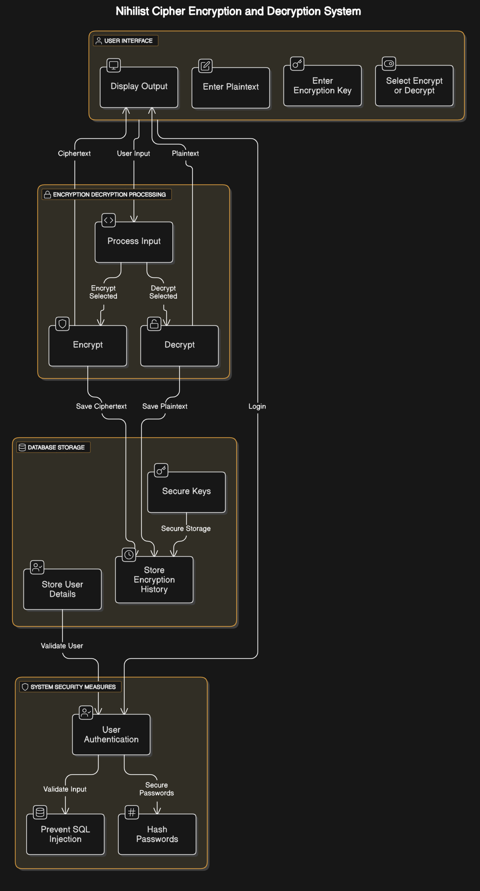

Existing System Diagram
Challenges with existing encryption systems include:
- High computational requirements.
- Complexity in key management.
- Limited offline usability.

3.5 Analysis of the Existing System
Existing cryptographic systems were analyzed using the following criteria:
- Security: The strength of encryption against attacks.
- Efficiency: The computational resources required for encryption and decryption.
- Usability: The ease with which users can interact with the system.
Findings revealed that while modern encryption techniques offer superior security, they are often complex and resource-intensive, making them impractical for lightweight applications.

3.6 Overview of the Proposed System
The proposed system is designed to implement the Nihilist Cipher for secure text encryption and decryption. The system will allow users to:
- Input plaintext and an encryption key.
- Encrypt the message using the Nihilist Cipher algorithm.
- Decrypt encrypted messages using the same key.
- Store and manage encryption history.
The system is developed as a web-based application that supports secure message encryption, decryption, and history tracking.
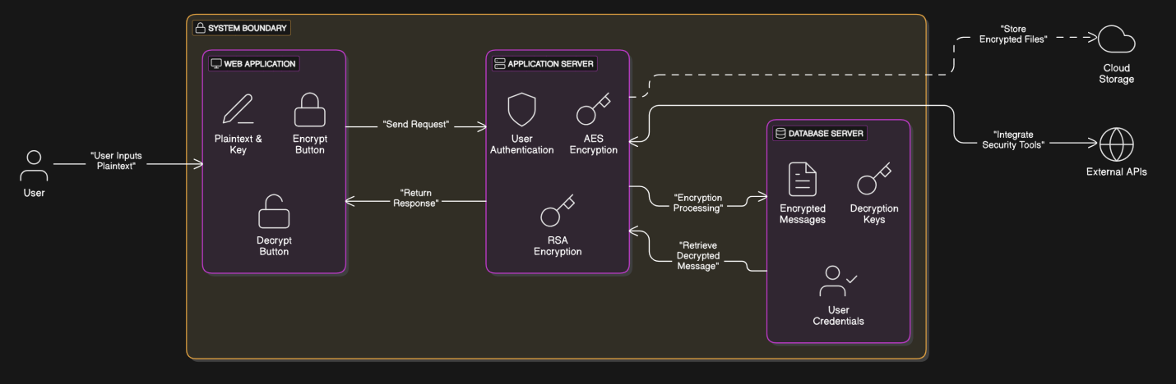

Proposed System Diagram

Use Case Diagram
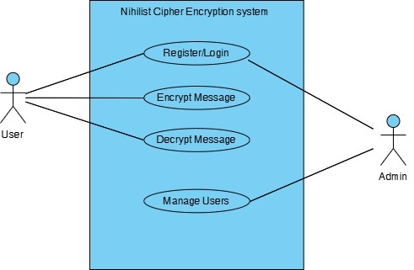

Use Case Diagram

3.7 Analysis of the Proposed System
The proposed system was analyzed based on its functionality, usability, and security. The analysis showed that:
- The system provides a simple and efficient way to encrypt and decrypt messages.
- Users can securely store and retrieve encrypted messages.
- The system is lightweight, making it ideal for low-power environments and offline encryption applications.

3.8 System Design
System design involves defining the architecture, components, and interactions within the system.

3.8.1 Logical Design
- Data Flow: Users input plaintext and a numeric key → The system processes encryption → Ciphertext is generated and stored.
- Database Design: The system uses a MySQL database to store users’ encryption history securely.
- Security Measures: The system ensures encrypted messages cannot be accessed without the correct key.

3.8.2 Physical Design
- User Interface: A web-based interface developed using Bootstrap and JavaScript.
- Backend Processing: Implemented using PHP and MySQL for database management.
- Data Storage: Messages are stored securely in a database with encryption applied.
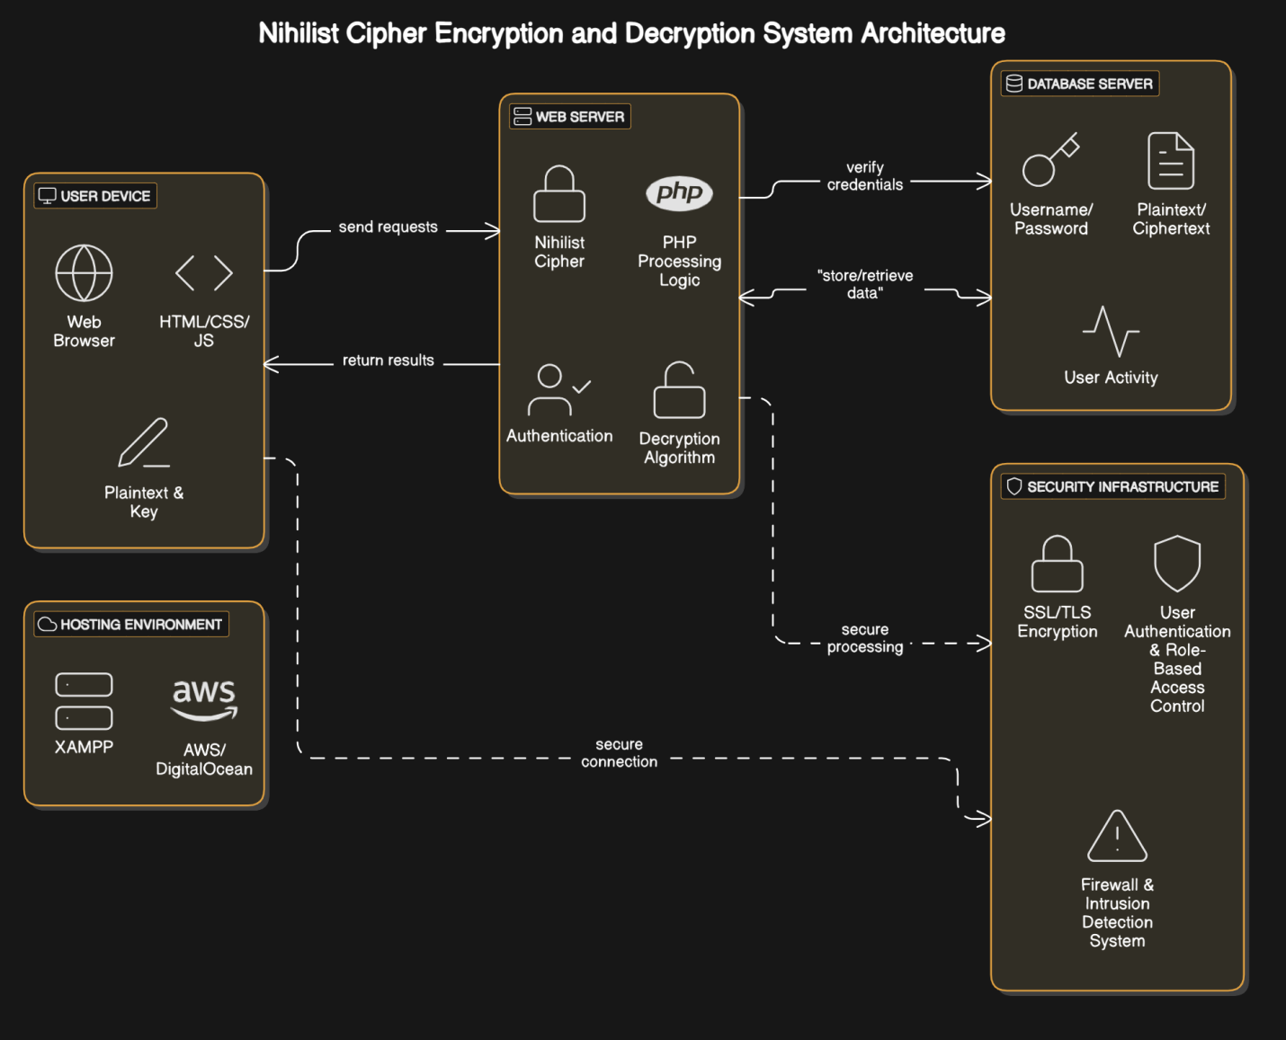

Physical Design Diagram
.

Entity-Relationship Diagram (ERD)
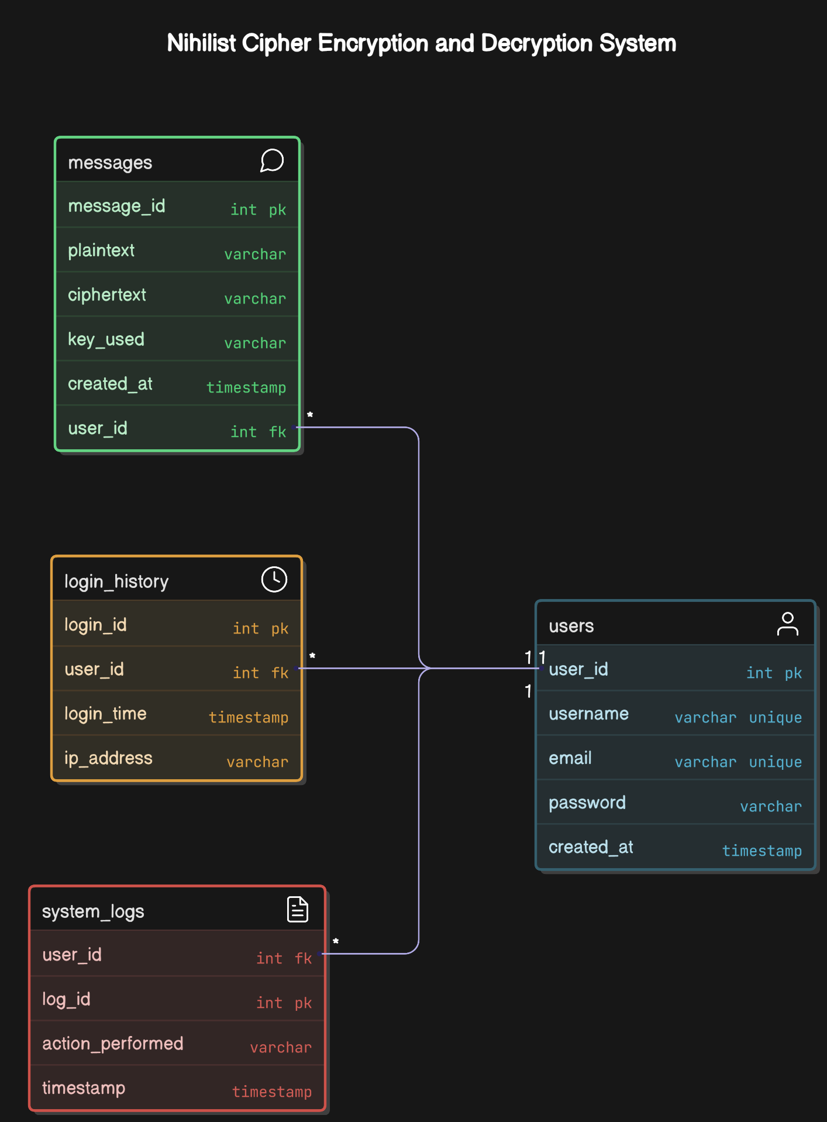

Entity Relation Diagram

CHAPTER FOUR

SYSTEM IMPLEMENTATION AND TESTING

4.1 Introduction
This chapter presents the implementation and testing of the Nihilist Cipher encryption and decryption system. It describes the system's development process, including the tools and technologies used, the system architecture, and the testing approaches adopted. The testing phase ensures that the system functions as expected and meets user requirements. Additionally, the chapter discusses the evaluation of the system’s performance and challenges encountered during the implementation.
System implementation is a crucial phase in software development as it involves translating theoretical designs into a working solution. This process includes writing and debugging code, configuring databases, setting up the necessary infrastructure, and integrating system components to ensure seamless communication between different modules. The Agile development approach was followed, allowing incremental improvements based on continuous feedback and testing.
Furthermore, system testing plays a pivotal role in verifying the correctness, security, and efficiency of the developed encryption and decryption mechanism. Various testing strategies were employed, such as unit testing, integration testing, and user acceptance testing (UAT) to assess the system’s functionality and ensure that it meets security and performance benchmarks. The evaluation process considered factors such as encryption accuracy, processing speed, and system reliability under different conditions.
Ultimately, the goal of this chapter is to provide a comprehensive overview of how the system was implemented, tested, and validated to ensure its effectiveness in securely encrypting and decrypting messages using the Nihilist Cipher algorithm.

4.2 System Implementation

4.2.1 Development Tools and Technologies
The system was developed using a combination of software tools and programming languages. The following technologies were utilized:
- Programming Language: PHP (for backend processing and encryption logic)
- Frontend Technologies: HTML, CSS, JavaScript, and Bootstrap (for UI design)
- Database Management System: MySQL (for storing user and message data)
- Web Server: XAMPP (for local server setup)
- Development Environment: Visual Studio Code and PHPMyAdmin (for database management)

4.2.2 System Architecture
The system follows a client-server architecture, where the user interacts with the system through a web interface, and the backend processes encryption and decryption requests. The architecture consists of the following components:
- User Interface: The frontend provides a simple form for inputting text and encryption keys.
- Application Layer: The backend processes encryption and decryption using the Nihilist Cipher algorithm.
- Database Layer: Stores encrypted messages and user information securely.
A flowchart and sequence diagram illustrate the interaction between these components.

4.3 System Testing

4.3.1 Testing Methodologies
To ensure the reliability and security of the system, different testing approaches were employed:
- Unit Testing: Each module, including encryption and decryption logic, was tested independently.
- Integration Testing: Ensured seamless communication between frontend, backend, and database.
- User Acceptance Testing (UAT): Real users tested the system to provide feedback on usability and performance.

4.3.2 Test Cases and Expected Results
Several test cases were designed to validate the correctness of the encryption and decryption functionality. Sample test cases include:
Test Case | Input | Expected Output
Encrypt Message | HELLO WORLD, Key: 4321 | Encrypted Text (Ciphertext)
Decrypt Message | Ciphertext, Key: 4321 | HELLO WORLD
Invalid Key | Incorrect Key for Decryption | Error Message

4.4 Evaluation of Results
The system was evaluated based on the following performance metrics:
- Encryption and Decryption Accuracy: Ensured that decrypted messages matched the original plaintext.
- System Speed: Assessed response time for encryption and decryption processes.
- User Feedback: Collected feedback from testers to improve UI and system performance.

4.5 Challenges and Limitations
During implementation and testing, the following challenges were encountered:
- Key Management Issues: Ensuring users enter valid numeric keys for encryption.
- Performance Optimization: Handling large text inputs efficiently.
- User Experience Considerations: Improving error handling and system feedback messages.

CHAPTER FIVE

SUMMARY, CONCLUSION, AND RECOMMENDATIONS

5.1 Introduction
This chapter presents a summary of the study, key findings, achievements, challenges encountered, and recommendations for future improvements. The chapter concludes with a final assessment of the Nihilist Cipher encryption and decryption system, emphasizing its contributions to cryptographic applications and potential areas for enhancement.

5.2 Summary of Findings
The study focused on designing and implementing an encryption and decryption system using the Nihilist Cipher. The following findings emerged from the research and system development process:
- The Nihilist Cipher provides a structured method for encrypting and decrypting text using numerical keys, enhancing security through transposition and substitution techniques.
- The system was successfully implemented using PHP, MySQL, and Bootstrap, providing a user-friendly web-based encryption tool.
- Testing confirmed the system's accuracy in encrypting plaintext and correctly decrypting ciphertext when the correct key was used.
- Challenges such as key management and text formatting were identified and addressed through systematic padding techniques and validation mechanisms.
- The system demonstrated efficiency in processing encryption and decryption requests with minimal computational overhead, making it suitable for lightweight security applications.

5.3 Achievements of the Study
The following objectives were achieved:
- A secure and functional encryption and decryption system based on the Nihilist Cipher was successfully developed.
- The system was designed with a user-friendly interface to ensure ease of use for encryption and decryption operations.
- Implementation of a database-driven encryption history feature, allowing users to retrieve past encrypted messages.
- Successful testing and validation of the system’s functionality, ensuring that the encryption and decryption processes operate correctly.
- Incorporation of security measures such as password hashing and input validation to enhance system security.

5.4 Challenges Encountered
During the course of the study, several challenges were encountered, including:
- Key Management Issues: Users needed to remember numeric keys for proper decryption, which could lead to usability concerns.
- Handling Special Characters and Spaces: The Nihilist Cipher traditionally works with letters only, requiring adjustments to process spaces and punctuation.
- Performance Optimization: Processing large text inputs required additional optimization to ensure system responsiveness.
- User Experience Improvements: Refining the system’s interface and feedback messages to enhance usability and prevent errors.

5.5 Recommendations
Based on the findings and challenges encountered, the following recommendations are proposed for future improvements:
- Enhanced Key Management: Implementing a key storage mechanism where users can securely retrieve keys without compromising security.
- Support for Additional Characters: Extending the system to handle numbers, punctuation, and special characters.
- Performance Enhancements: Optimizing database queries and encryption processing for faster execution.
- Mobile Compatibility: Developing a mobile-friendly version of the encryption tool for broader accessibility.
- Integration with Modern Security Protocols: Combining the Nihilist Cipher with other cryptographic techniques for enhanced security in real-world applications.

REFERENCES
Kahn, D. (2018). The Codebreakers: The Comprehensive History of Secret Communication from Ancient Times to the Internet. Scribner.
Menezes, A. J., van Oorschot, P. C., & Vanstone, S. A. (2020). Handbook of Applied Cryptography. CRC Press.
Schneier, B. (2020). Applied Cryptography: Protocols, Algorithms, and Source Code in C. Wiley.
Stallings, W. (2017). Cryptography and Network Security: Principles and Practice. Pearson Education.
Diffie, W., & Hellman, M. E. (1976). New directions in cryptography. IEEE Transactions on Information Theory, 22(6), 644-654. https://doi.org/10.1109/TIT.1976.1055638
Rivest, R. L., Shamir, A., & Adleman, L. (1978). A method for obtaining digital signatures and public-key cryptosystems. Communications of the ACM, 21(2), 120-126. https://doi.org/10.1145/359340.359342
Shannon, C. E. (1949). Communication theory of secrecy systems. Bell System Technical Journal, 28(4), 656-715. https://doi.org/10.1002/j.1538-7305.1949.tb00928.x
Ferguson, N., & Schneier, B. (2003). Practical cryptography. Proceedings of the RSA Conference, 12(3), 45-56.
National Institute of Standards and Technology (NIST). (2001). Advanced Encryption Standard (AES). https://nvlpubs.nist.gov/nistpubs/FIPS/NIST.FIPS.197.pdf
Open Web Application Security Project (OWASP). (2022). Cryptographic storage cheatsheet. https://owasp.org/www-project-cheatsheets/cheatsheets/Cryptographic_Storage_Cheat_Sheet.html
Cisco Systems. (2021). Cybersecurity threats and trends 2021. https://www.cisco.com/cybersecurity-trends
Microsoft Security Blog. (2022). The evolution of cryptographic security in cloud computing. https://www.microsoft.com/security/blog/2022/05/10/cryptographic-security-evolution/
XAMPP. (2023). XAMPP documentation and setup guide. https://www.apachefriends.org/docs/
Lucidchart. (2023). How to create flowcharts and ER diagrams. https://www.lucidchart.com/resources/

APPENDIX

Appendix A: System Screenshots
This section contains screenshots of the implemented Nihilist Cipher encryption and decryption system, demonstrating its user interface and functionality.
- Login Page

- Registration Page

- Encryption Result

- Decryption Result

- Encryption History Page
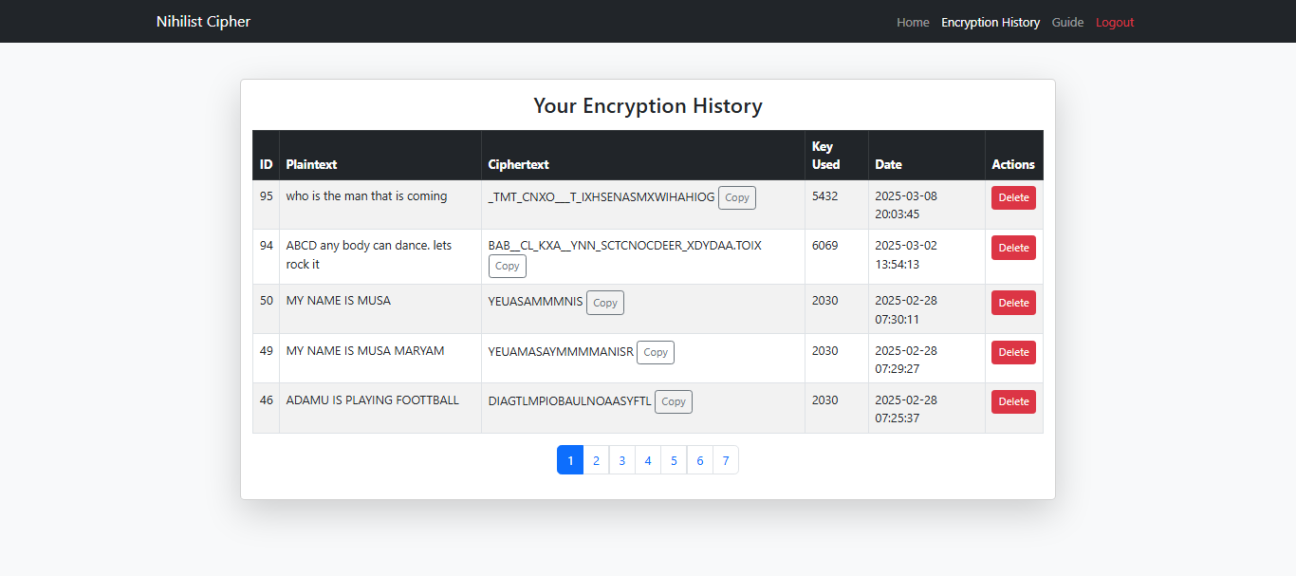

Appendix B: Database Schema
The following tables describe the database schema used in the system:
- Users Table
  - user_id (Primary Key, Auto-Increment)
  - username (VARCHAR, Unique)
  - email (VARCHAR, Unique)
  - password (VARCHAR, Hashed)
  - created_at (TIMESTAMP)
- Messages Table (Encryption History)
  - message_id (Primary Key, Auto-Increment)
  - user_id (Foreign Key References Users)
  - plaintext (VARCHAR)
  - ciphertext (VARCHAR)
  - key_used (VARCHAR)
  - created_at (TIMESTAMP)
- Login_History Table (Optional Security Tracking)
  - login_id (Primary Key, Auto-Increment)
  - user_id (Foreign Key References Users)
  - login_time (TIMESTAMP)
  - ip_address (VARCHAR)

Appendix C: Source Code Snippets

Encryption Function (PHP Implementation)
function encryptNihilist($plaintext, $key) {
$plaintext = strtoupper(str_replace(' ', '', $plaintext));
$keyArray = str_split($key);
$keyLength = count($keyArray);
while (strlen($plaintext) % $keyLength !== 0) {
$plaintext .= 'X';
}
$columns = array_fill(0, $keyLength, "");
for ($i = 0; $i < strlen($plaintext); $i++) {
$columns[$i % $keyLength] .= $plaintext[$i];
}
usort($keyArray, function ($a, $b) {
return $a <=> $b;
});
$ciphertext = "";
foreach ($keyArray as $index) {
$ciphertext .= $columns[$index];
}
return $ciphertext;
}

Decryption Function (PHP Implementation)
function decryptNihilist($ciphertext, $key) {
$keyArray = str_split($key);
$keyLength = count($keyArray);
$rows = strlen($ciphertext) / $keyLength;
usort($keyArray, function ($a, $b) {
return $a <=> $b;
});
$columns = array_fill(0, $keyLength, "");
$index = 0;
foreach ($keyArray as $sortedKey) {
$columns[$sortedKey] = substr($ciphertext, $index, $rows);
$index += $rows;
}
$plaintext = "";
for ($i = 0; $i < $rows; $i++) {
for ($j = 0; $j < $keyLength; $j++) {
$plaintext .= $columns[$j][$i] ?? "";
}
}
return rtrim($plaintext, 'X');
}

